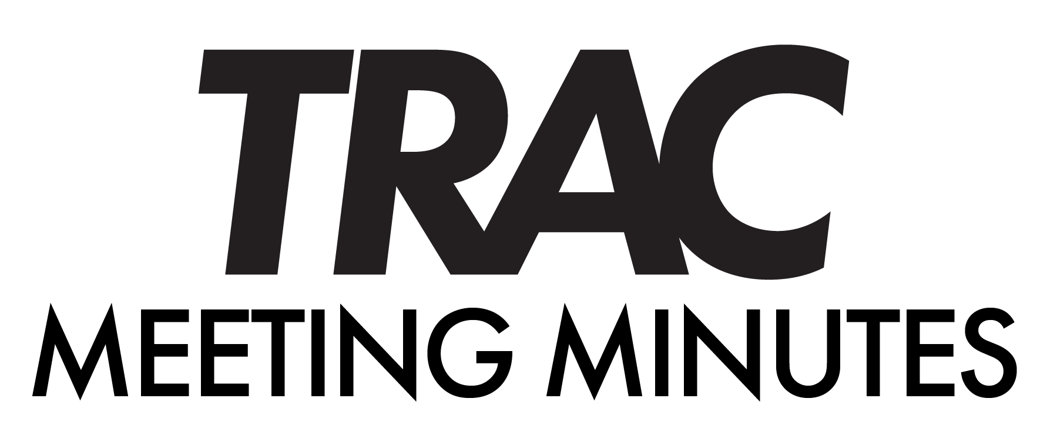
DES MOINES AREA REGIONAL TRANSIT AUTHORITY
TRANSIT RIDERS ADVISORY COMMITTEE
october 30, 2024 – noon
Hybrid Meeting

[The above TRAC Meeting was hybrid – in person at DART Central Station and virtual via Zoom. The Committee determined that it is convenient to offer this option to members of the Committee, staff and members of the public to accommodate for concerns related to the Covid-19 pandemic.]

TRAC Members Present:
Todd Kilzer, Laurie Jones, MaryAnn Ryan, Kaylynn Strain, Brandon Paulsen, Lee Jasinski, Matthew Shankles, James Hanold, David Campbell, Jeremy Guenther, Justin Bates

TRAC Members Absent:

DART Staff Present:
Catlin Curry, Jan Keeling, Lewis Lowry, Matt Harris, Sarah Welch, Brandon Anderson, Erin Hockman, Amanda Wanke, Kelley Burgess

ROLL CALL AND ESTABLISHMENT OF QUORUM
The meeting was called to order by Brandon Paulsen at 12:00p.m.
Roll call was taken, and quorum was met.

- APPROVAL OF MEETING MINUTES
The September 25, 2024 minutes were approved.
The motion was approved by James Hanold and seconded by Lee Jasinski.

- PUBLIC COMMENT
Garland Armstrong: Fiscal cliff concerns. He has asked PACE to send DART a 2025 budget book. “We are all in this together”.

- DISCUSSION ITEMS

- MEMBER COMMUNITY UPDATE (Amanda Wanke / Erin Hockman)
Amanda emphasized the importance of advocacy for transportation and discussed the progress made in the recent Commission Reimagine DART Workshop.

Erin spoke on Reimagine DART Budget Scenarios. At the November TRAC meeting expect to be able to share opportunities for TRAC to meet with the consultants.
- What level of service should we fund?
  - Smaller network – 20% less service
  - Status quo
We will provide service based on what the cities are willing to fund.

- OTHER BUSINESS

  - UZURV Update (Lewis Lowry)
Lewis updated TRAC about UZURV launching in the next few weeks. UZURV will fill in with Paratransit rides as overflow taxi service. Drivers are FTA compliant.

  - TRAC Membership Updates (Catlin)
Catlin went over the procedures for outgoing and incoming members. With Reimagine DART, we feel it is best to retain Kaylynn and Brandon and just have one new member joining us.
In November meeting we will be nominating for Chair and Vice Chair positions, with voting taking place in the December meeting.

  - HR Update (Kelley)
Kelley and Erin presented Catlin with a Customer Service Impact award – given in recognition of Catlin’s excellent service to the community.

- TRAC MEMBER COMMUNICATIONS

- FUTURE AGENDA ITEMS

- UPCOMING MEETINGS
  - DART Commission – Noon, Tuesday, November 5, 2024 – Zoom / DCS

  - TRAC – Noon, Wednesday, November 20, 2024 – Zoom / DCS

- ADJOURN
Catlyn adjourned the meeting at 12:49pm.
It was moved by Todd Kilzer and seconded Lee Jasinski.
The motion carried unanimously.

